**Exercise 3: Stored Procedures**

**Scenario 1:**The bank needs to process monthly interest for all savings accounts.

* + **Question:** Write a stored procedure **ProcessMonthlyInterest** that calculates and updates the balance of all savings accounts by applying an interest rate of 1% to the current balance.

**Answer:**

CREATE OR REPLACE PROCEDURE ProcessMonthlyInterest AS

BEGIN

FOR acc_rec IN (

SELECT AccountID, Balance

FROM Accounts

WHERE AccountType = 'Savings'

) LOOP

UPDATE Accounts

SET Balance = Balance + (acc_rec.Balance * 0.01)

WHERE AccountID = acc_rec.AccountID;

END LOOP;

COMMIT;

END;

/

EXEC ProcessMonthlyInterest;

**OUTPUT:**

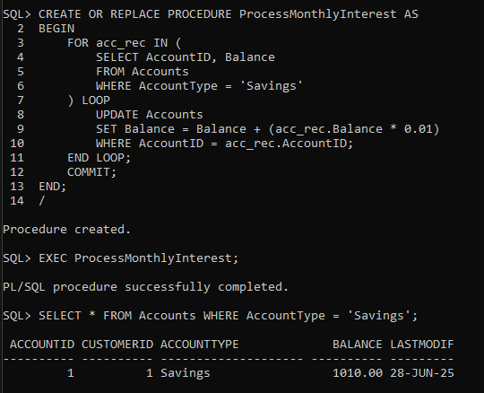

**Scenario 2:**The bank wants to implement a bonus scheme for employees based on their performance.

* + **Question:** Write a stored procedure **UpdateEmployeeBonus** that updates the salary of employees in a given department by adding a bonus percentage passed as a parameter.

**Answer:**

CREATE OR REPLACE PROCEDURE UpdateEmployeeBonus(

dept_name IN VARCHAR2,

bonus_percent IN NUMBER

) AS

BEGIN

UPDATE Employees

SET Salary = Salary + (Salary * bonus_percent / 100)

WHERE Department = dept_name;

COMMIT;

END;

/

EXEC UpdateEmployeeBonus('IT', 10);

**OUTPUT:**

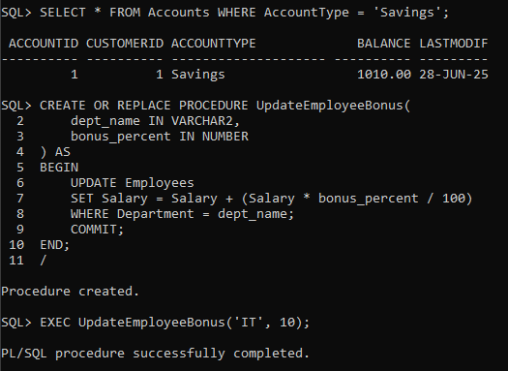

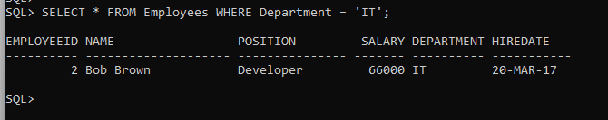

**Scenario 3:**Customers should be able to transfer funds between their accounts.

* + **Question:** Write a stored procedure **TransferFunds** that transfers a specified amount from one account to another, checking that the source account has sufficient balance before making the transfer.

**Answer:**

CREATE OR REPLACE PROCEDURE TransferFunds(

from_acc IN NUMBER,

to_acc IN NUMBER,

amount IN NUMBER

) AS

balance_from NUMBER;

BEGIN

SELECT Balance INTO balance_from

FROM Accounts

WHERE AccountID = from_acc;

IF balance_from >= amount THEN

UPDATE Accounts

SET Balance = Balance - amount

WHERE AccountID = from_acc;

UPDATE Accounts

SET Balance = Balance + amount

WHERE AccountID = to_acc;

COMMIT;

DBMS_OUTPUT.PUT_LINE('Transfer done.');

ELSE

DBMS_OUTPUT.PUT_LINE('Not enough balance.');

END IF;

END;

/

SET SERVEROUTPUT ON;

EXEC TransferFunds(1, 2, 500);

**OUTPUT:**

